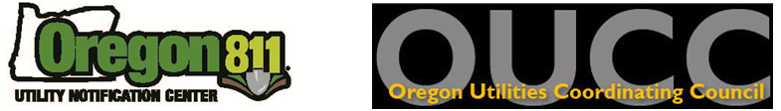

ADDITIONAL FUNDING REQUEST FORM
- The purpose of Additional Funding is to help Councils with their P&E Events and training, when there is not enough money in that Council to fund it completely themselves.
- In order to provide accountability of spending to the OUNC, additional information is required. Please fill out this form as completely as you are able to.
The OUCC requests the following information from you.
Requesting Council: Select your Council

Today’s Date: Click to enter a date  Office(s) held:  ☐President ☐Vice President ☐Treasurer  ☐Secretary ☐Damage Chair ☐P&E Chair  ☐Standards Chair  ☐Other Add Title/Chair held | Name of Person Requesting Funding:  Click to add Name  Mailing Address: Add Street Address  City / State / Zip: Add City, State, Zip
__________________________________________________________________________________________________________________________
Event or Purpose for Request (with description): Click to add Event Name
Date of Event: Click to select Event Date Location of Event: Click to add Location
Is there a web link to this event? ☐No ☐Yes - Click to add Link
Can it be added to the OUCC Calendar? ☐No ☐Yes

Are you requesting other promotional materials?
☐No ☐Yes : Click to add items
__________________________________________________________________________________________________________________________
Amount of funds in your UCC account prior to this event/training: $
Amount of Request: $ Amount your UCC is contributing: $

Please list any additional events you plan to sponsor through the rest of this year with estimated expenditure:
$ | Date: Add date | Event: Click to add Event Name
$ | Date: Add date | Event: Click to add Event Name
$ | Date: Add date | Event: Click to add Event Name
$ | Date: Add date | Event: Click to add Event Name

Please submit your request to the Treasurer at alba.vogland.oucc@gmail.com for Board review and approval.

